**Test Execution Log and Screenshots**

|  |  |
| --- | --- |
| **Test Script ID** | TEST01 |
| **Test Script Description** | TEST01_Launch Cyclos and Perform a Payment to system |
| **Executed by** | Testing |
| **Executed Date & Time** | 07/31/2018 3:43:05 PM |
| **Test Status** | **Failed** |

Step Name: Step Name: Step_1   
Step Details: Click Signin button  
Expected Result: Signin button should be clicked  
Actual Result: Signin button is clicked  
Result: Passed

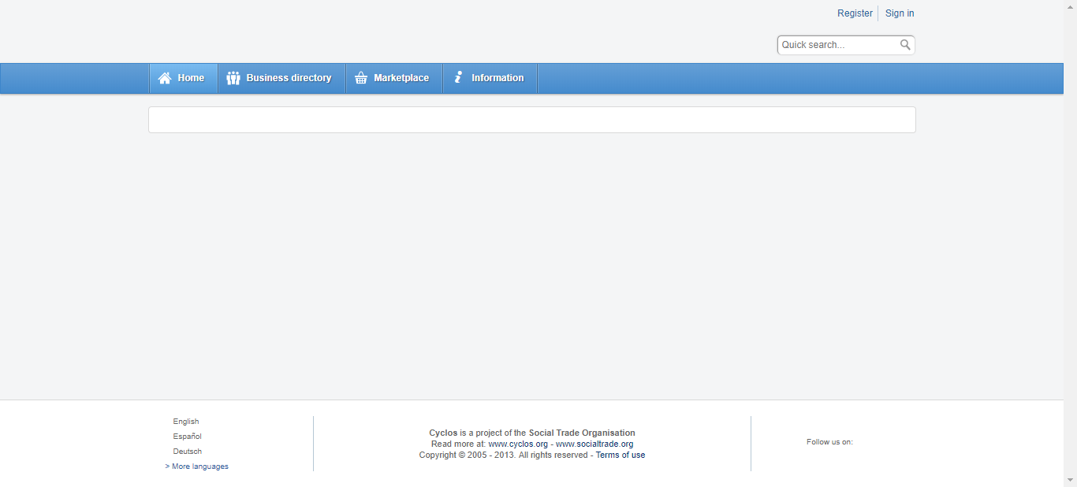

Step Name: Step Name: Step_2   
Step Details: Enter UserName  
Expected Result: Username should be entered  
Actual Result: Username is entered  
Result: Passed

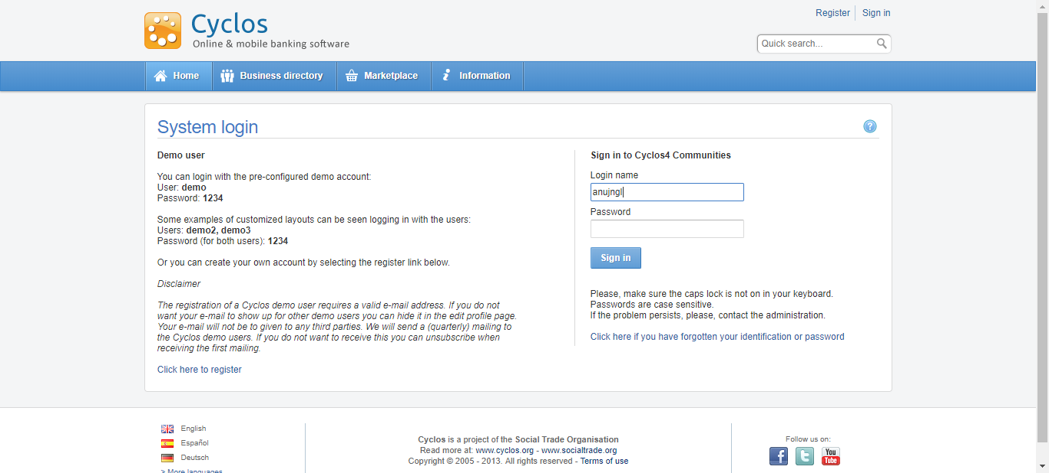

Step Name: Step Name: Step_3   
Step Details: Enter Password  
Expected Result: Password should be entered  
Actual Result: Password is entered  
Result: Passed

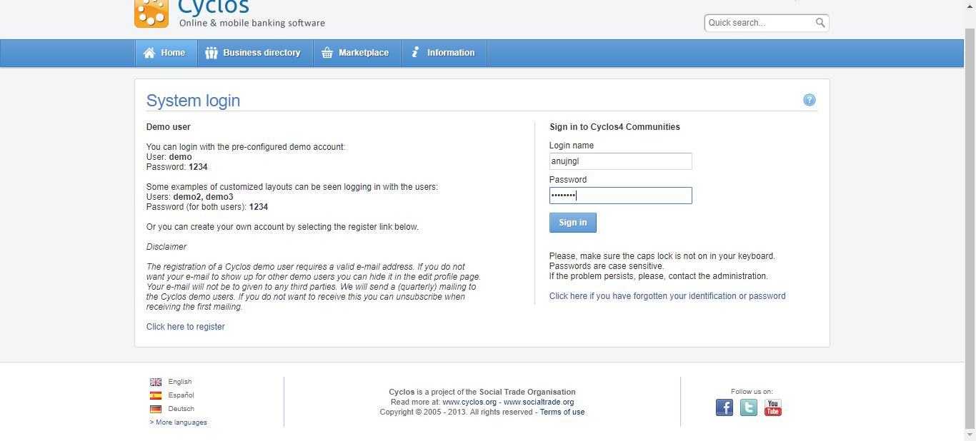

Step Name: Step Name: Step_4   
Step Details: Click Login button  
Expected Result: Login button should be clicked  
Actual Result: Login button is clicked  
Result: Passed



Step Name: Step Name: Step_5   
Step Details: Click Banking Menu  
Expected Result: Banking Menu should be clicked  
Actual Result: Banking Menu is clicked  
Result: Passed

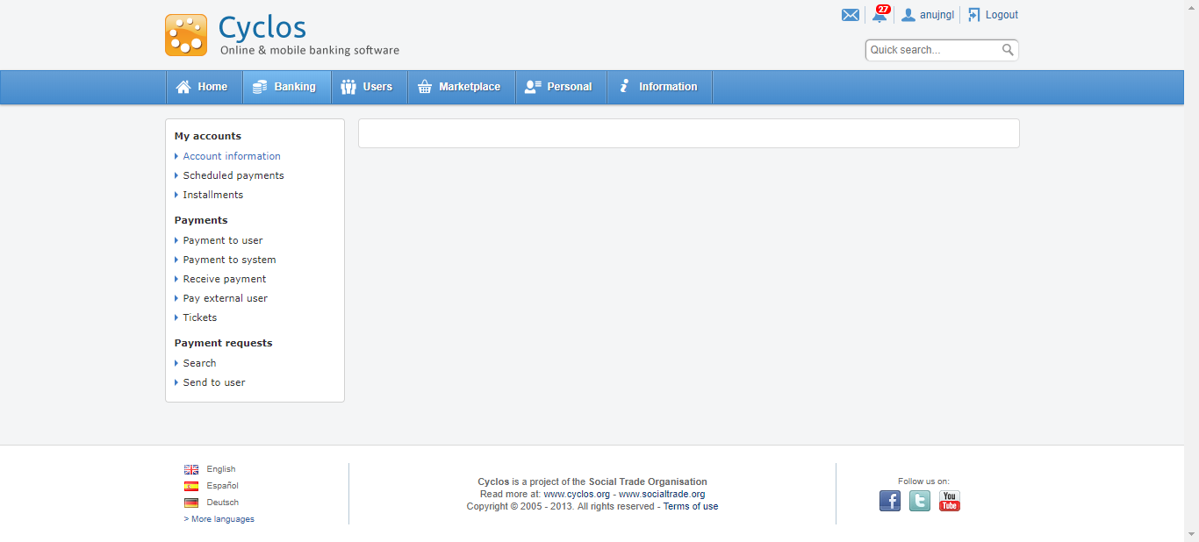

Step Name: Step Name: Step_6   
Step Details: Click Payment to System tab  
Expected Result: Payment to System tab should be clicked  
Actual Result: Payment to System tab is clicked  
Result: Passed

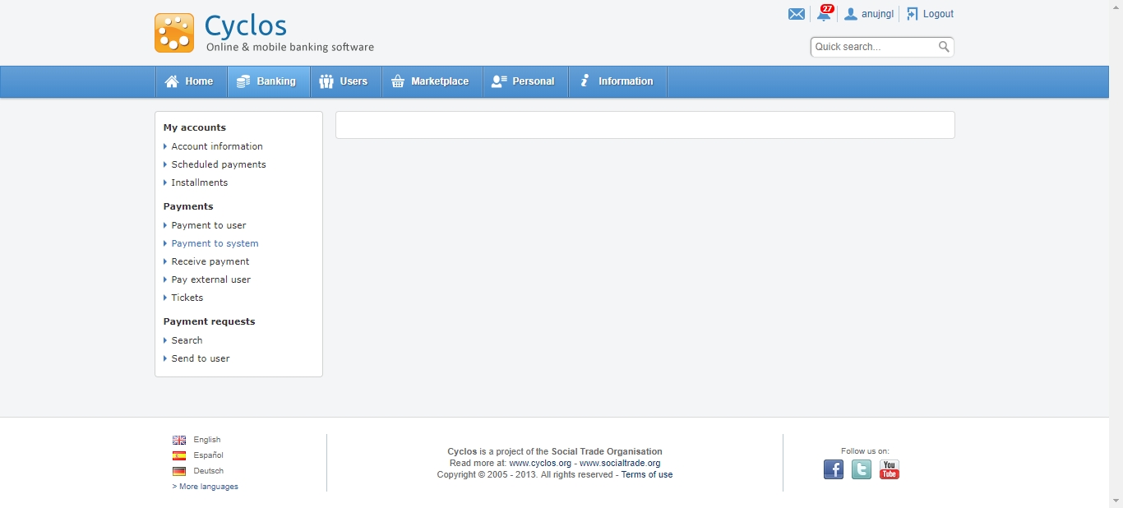

Step Name: Step Name: Step_7   
Step Details: Enter the given amount  
Expected Result: Amount 10.0 should be entered  
Actual Result: System encountered a failure while trying to enter the data 10.0 into the web element, Reason:Expected condition failed: waiting for element to be clickable: By.xpath: /html/body/div[3]/div[3]/div/div/div[2]/div[2]/div[2]/div/div/table/tbody/tr[5]/td[2]/table/tbody/tr/td[1]/table/tbody/tr/td[1]/input (tried for 3 second(s) with 500 milliseconds interval)  
Result: Failed

